Modeling the Viability of a Refrigeration-Based Atmospheric Water Generator under the Present-Day Climate

* The saturation specific humidity (qs) at any given atmospheric pressure (Patm) and temperature T (e.g., dew point Tdew or the condenser temperature Tc) can be estimated using the August-Roche-Magnus equation in (1). The saturation specific humidity at the condenser temperature can be estimated using (2). Similarly, from the ambient air pressure and specific humidity, dew point temperature Tdew can be estimated using (4).

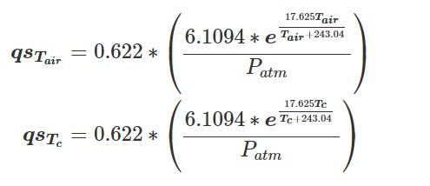

1

2

* The relative humidity RH of the atmosphere is the specific humidity of the moist air (qair) divided by the saturation specific humidity of the air at ambient temperature:

RH=qair/qsTair 3)

* The dew point of the atmosphere is:

4) 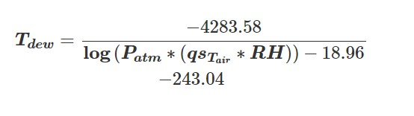

* If the temperature of the cold side of the heat pump (Tc) is greater than dew point, then the system will not be able to produce water. If Tc is less than 0°C, the condenser will make frost, which is assumed to be not useful, since it would clog the heat exchanger. However, if a frost scraping and melting device were to be implemented, subfreezing dew points would not be a problem. This is outside the scope of this model.

The quantity delta (Δ) represents the amount of water available per unit mass of moist air input:

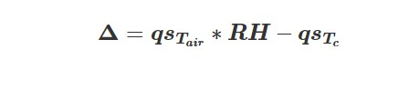5)

* Therefore the potential water output (m˙water) for a given mass flow rate of moist air input (m˙air) can be estimated as:

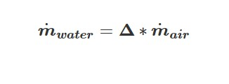6)

* When the air is cooled and water condenses, latent heat is released. This latent heat flux is directly correlated with heat pump energy consumption and must be quantified. First, the flux of dry air and vapor entering the system respectively can be calculated as follows:

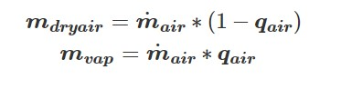

7)

* Given the specific heats cpair, cpwater, cpvap, and the heat of vaporization of water ΔHvap, various terms of the system energy budget can be calculated. The first is the energy released from the cooling of the dry air from ambient to the condenser temperature (E1). This is:

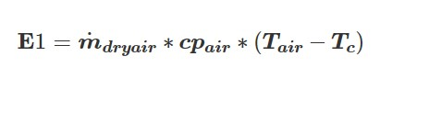8)

* The cooling of the water vapor to dew point from ambient temperature can be represented by E2:

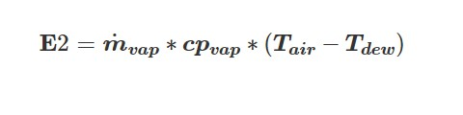

9)

* The condensation of the entire quantity of liquid water is assumed to happen at dew point. In reality, it would take place throughout the thickness of the heat exchanger, since as the air enters the heat exchanger and reaches Tdew, RH=100% and water begins to condense. As the temperature continues to decrease through the matrix of heat exchanger fins, RH stays at 100% while water continues to condense. The approximation to this latent heat release is E3:

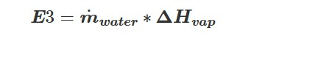

10)

* It is assumed that the liquid water remains within the heat exchanger long enough to be cooled to Tc. As mentioned before, this assumes that all of the water is condensed at Tdew. Since cpwater is greater than cpvap, this will result in a slight overestimate of energy requirements, which is advantageous when designing the energy supply for the device. This energy (E4) is:

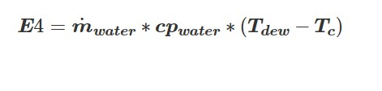11)

* Finally, the water vapor that was not condensed from the original quantity of vapor is cooled, and the energy released can be represented by E5:

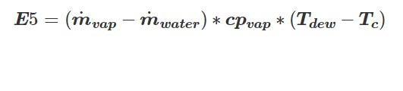12)

Knowing the energy contributions of each process, the total energy Etot absorbed by the heat exchanger is:

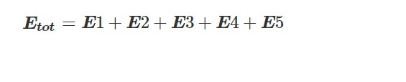

13)

If the intent is to model a system using the ground temperature (Tgr) as the condenser temperature, the above equations apply with Tc equal to Tgr. For use with a heat pump, there is much flexibility with the value of Tc. Two broad schemes are considered:

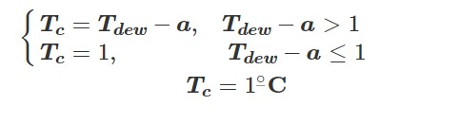

14)

* In the first scheme, the variable a is a constant that can be set by the user. This sets condenser temperature to a constant temperature difference below the air temperature, except for when the difference would cause Tc to be less than or equal to 0. As a buffer against thermostat error, the minimum condenser temperature could be set to 1, or any other arbitrary value, based on thermostat accuracy.
* The second scheme, which would maximize water output but increase energy consumption, is to set Tc to a value close to 0 (as in the first scheme, this depends on thermostat design; the more accurate the thermostat is, the closer it can be set to 0), to ensure that the condenser produces liquid water as opposed to frost.

To estimate energy needs for the heat pump, the ideal case is a Carnot cycle heat pump. The heat pump is using the ground as the hot thermal reservoir (i.e. the heat pump rejects heat to the ground in order to cool the water generator's water condensing surface). Using temperatures in Kelvin, the maximum coefficient of performance (βmax) of a Carnot cycle heat pump is:

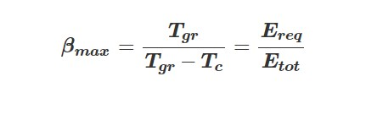

15)

Ereq is the amount of energy required to remove the amount of energy Etot from the cold reservoir. Therefore,

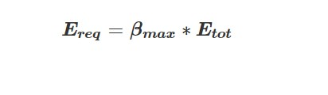

16)

If the user has β data for the heat pump included with the device, this can also be substituted into the program.